Euclidean distance –

The distance between two points in space along a straight line.

How use this-

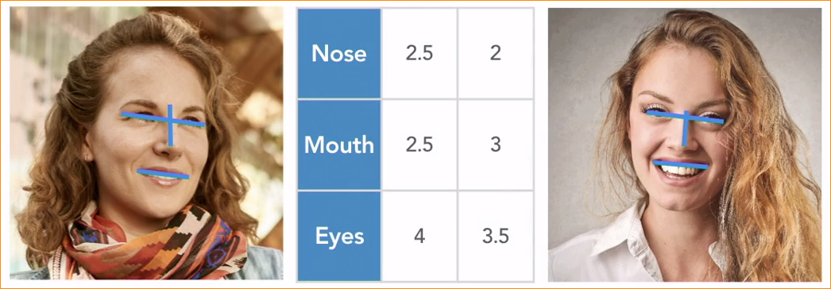

It can be heard to visualize a model with 128 measurements.

Do simply –

Manually take three measurements from both theses faces.

Visualize those three parameters-

Draw a straight line between them. This line is the Euclidean distance between theses two faces.

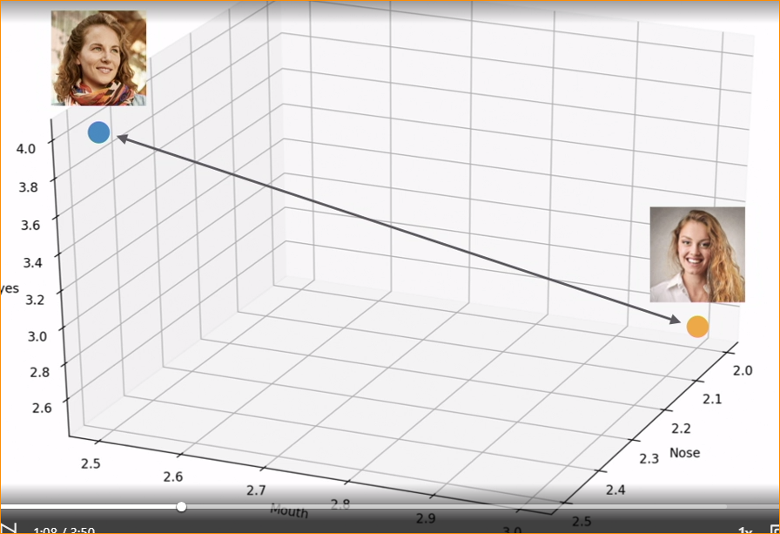

Face distance threshold –

Set a face maximum distance that is still considered the same face .

Lets assume the threshold value is 0.6.

* If the distance (a,b) > 0.6, not , match
* If the distance (a,b) =< 0.6, they match
* The lower the distance , the better the match

Calculating Euclidean Distance –

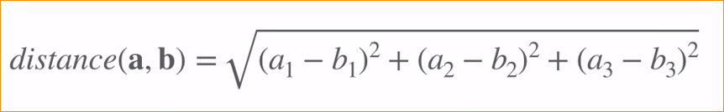

A1 – 2.5 a2 = 2.5 and a3 = 4

B1= 2 , b2 = 3 and b3 = 3.5

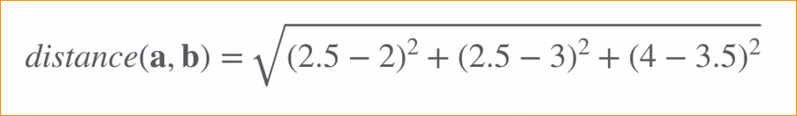

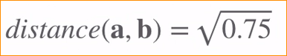



This is the distance between two faces.

This is over 0.6 threshold value that mean faces are not match.

* Calculating Euclidean Distance of 128 points

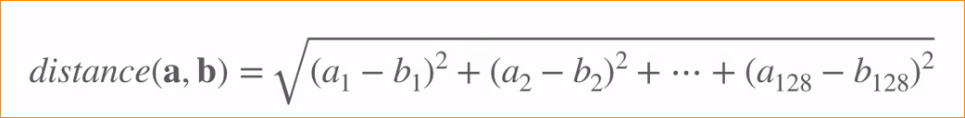

Advance of Using Euclidean Distance-

* Has lot of nice properties.
* Fast to Euclidean distance calculate and easy to parallelize.
* Working nicely with other common machine learning algorithms, like k-nearest neighbors(KNN)
* Makes it easy to store and query face measurements using a standard database.

Code –



Load the images –

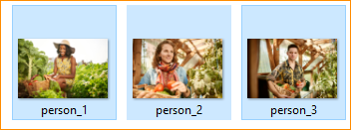

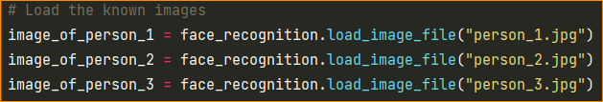

Calculate the face encodings of the each images.

In here we only contain one face so we take 1st element.[0] index 0. 1st result

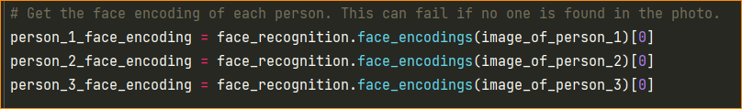

Put calculate values in the another list-

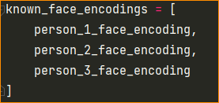

Now open unknown 8 image. And load the image.

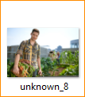

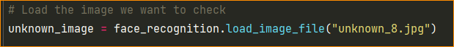

Calculate each encoding values –

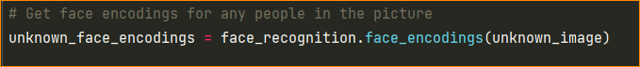

Compare which one is match ?

So in here that list we put to loop and take one by one element.

And using compare method – compare_faces (known, unknown) and compare with tolerance

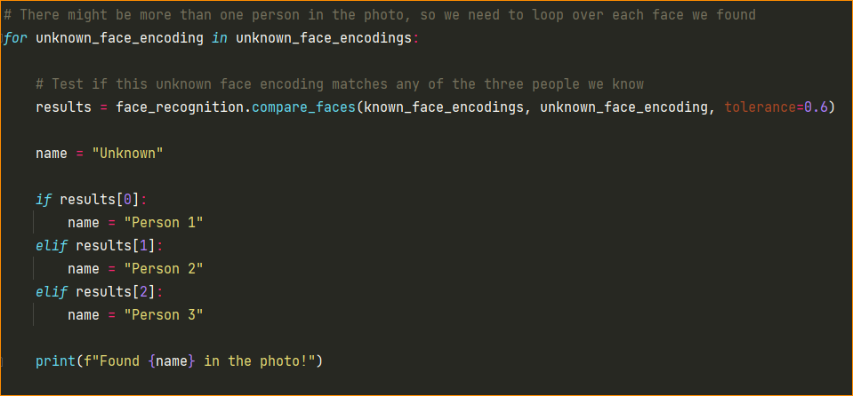

Here we take most suitable image=- Result Person 03



Face recognition working in different scenarios –

In here recognize 3 people in 3 sample data



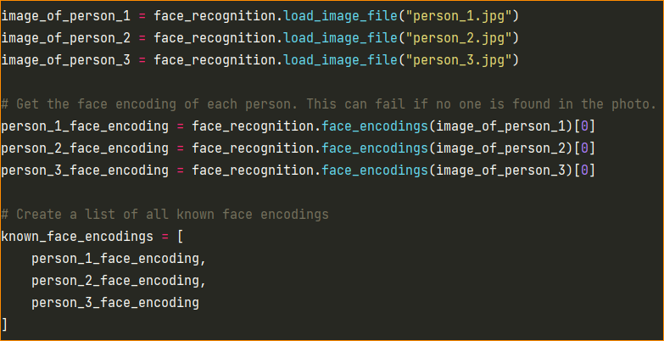

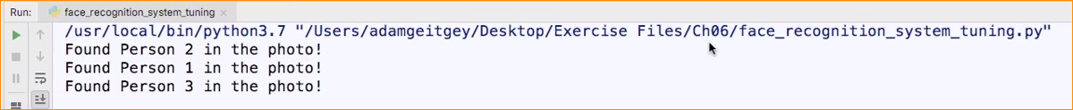

So in here we use unclear image –

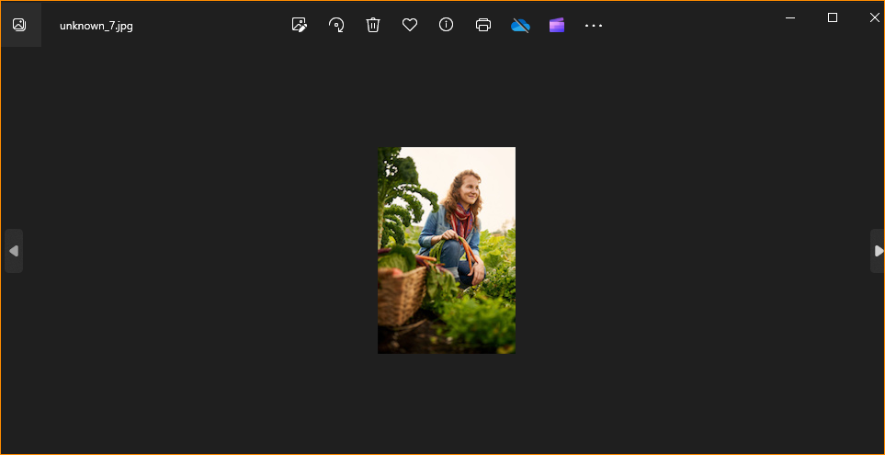

In here model not given any result- So that we use another function call face_location

And pass value to encoding with known_face_location

 this mean we enlarge the photo.

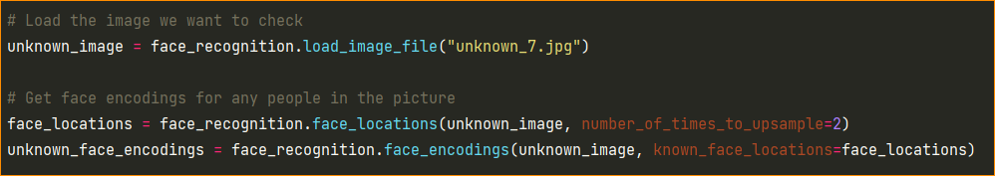

Now model choose the person.